**Problem 01**

Write a program using WHILE statement that displays a right triangle using asterisks where the height is at the left corner of the application. The height will depend on the user input.

**Solution and Testing 01**

Below is the screenshot of solution program as well as testing in the terminal.

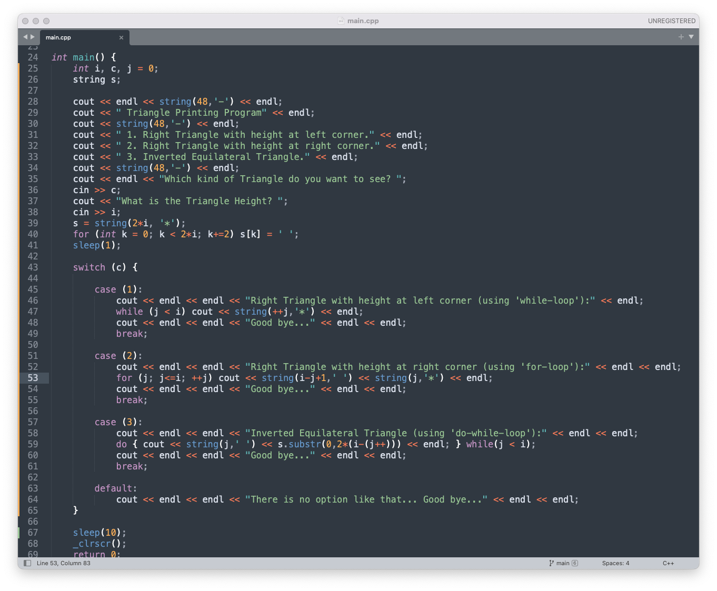

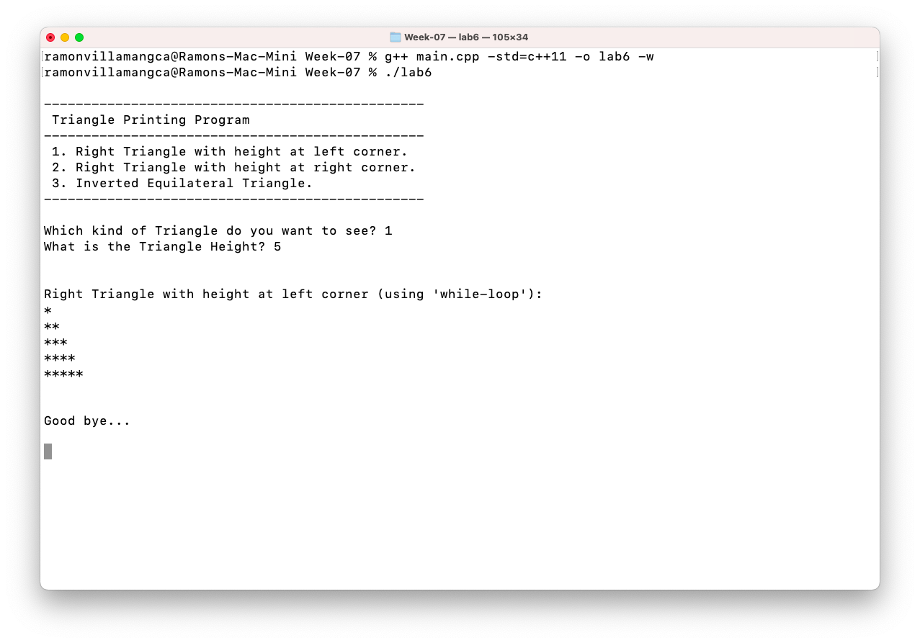

**Problem 02**

Write a program using FOR statement that displays a right triangle using asterisks where the height is at the right corner of the application. The height will depend on the user input.

**Solution and Testing 02**

Below is the screenshot of solution program as well as testing in the terminal.



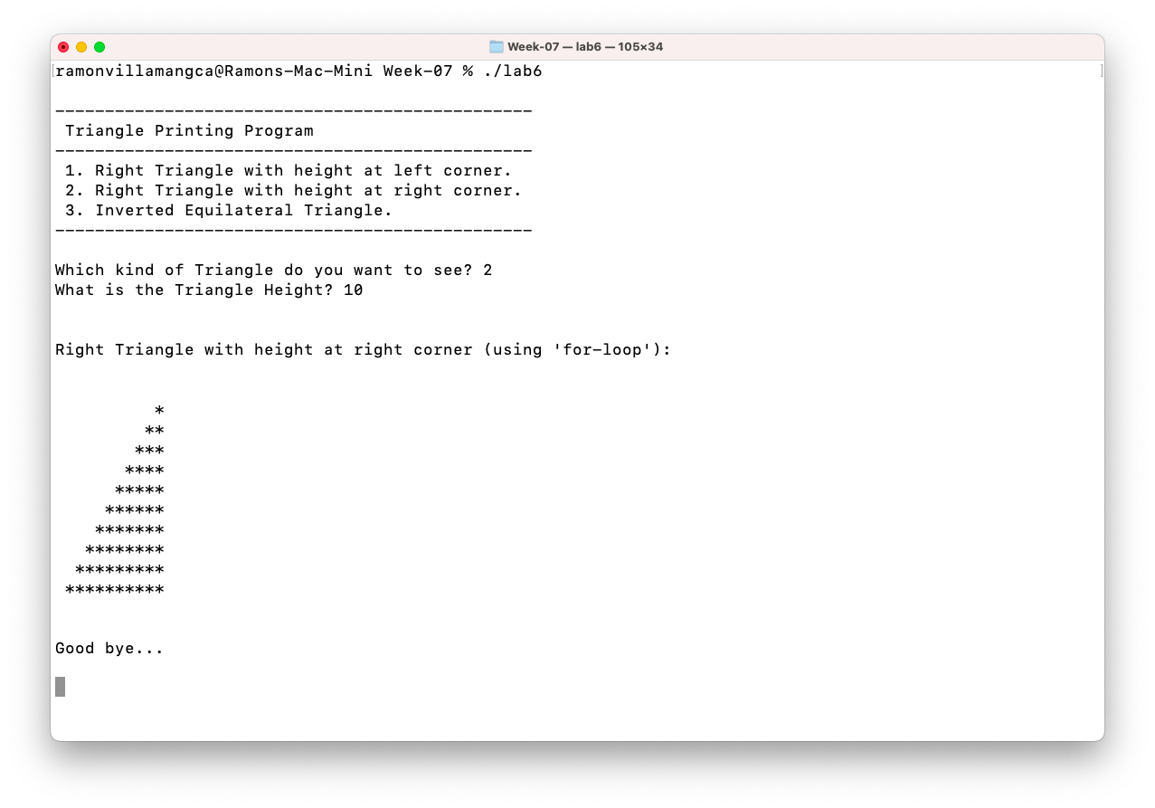

**Problem 03**

Write a program using DO WHILE statement that displays an inverted equilateral triangle using asterisks. No asterisk should be adjacent to one another. The height will depend on the user input.

**Solution and Testing 03**

Below is the screenshot of solution program as well as testing in the terminal.



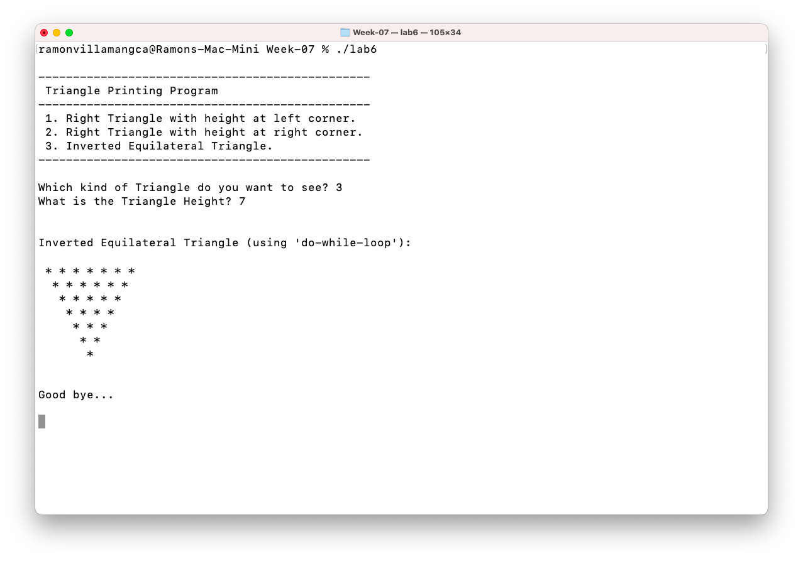

**Problem 04**

What can you conclude from this activity?

**Answer 04**

The solutions presented may not be the exact solutions the problem creator had in mind. But the solutions work and do **satisfy the problem specification**. There is always more than one way to solve a programming problem.

------------------------

**NOTE FOR THIS PROBLEM:**

Source code can be found on my GitHub page: <https://github.com/rvillamangca/>.